**Lab 14: NetWitness**

Installing NetWitness

Open a browser and go to

Click "Download NetWitness Investigator Freeware"

Fill in the form and click Submit.

A NwInvestigatorSetup.exe file downloads (131 MB).

Install the software with the default options.

On your desktop, double-click the "NetWitness Investigator 9.6" icon.

A "NetWitness Investigator 9" window opens. Warning boxes pop up, saying "Revocation information for the security certificate for this site is not available...".

Click Yes to bypass the warnings.

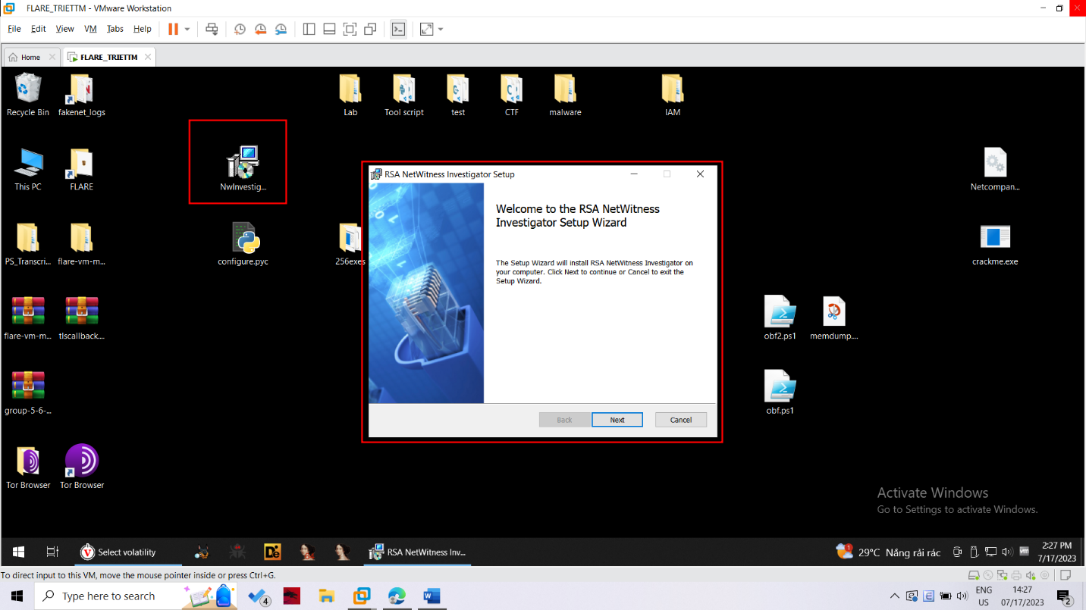

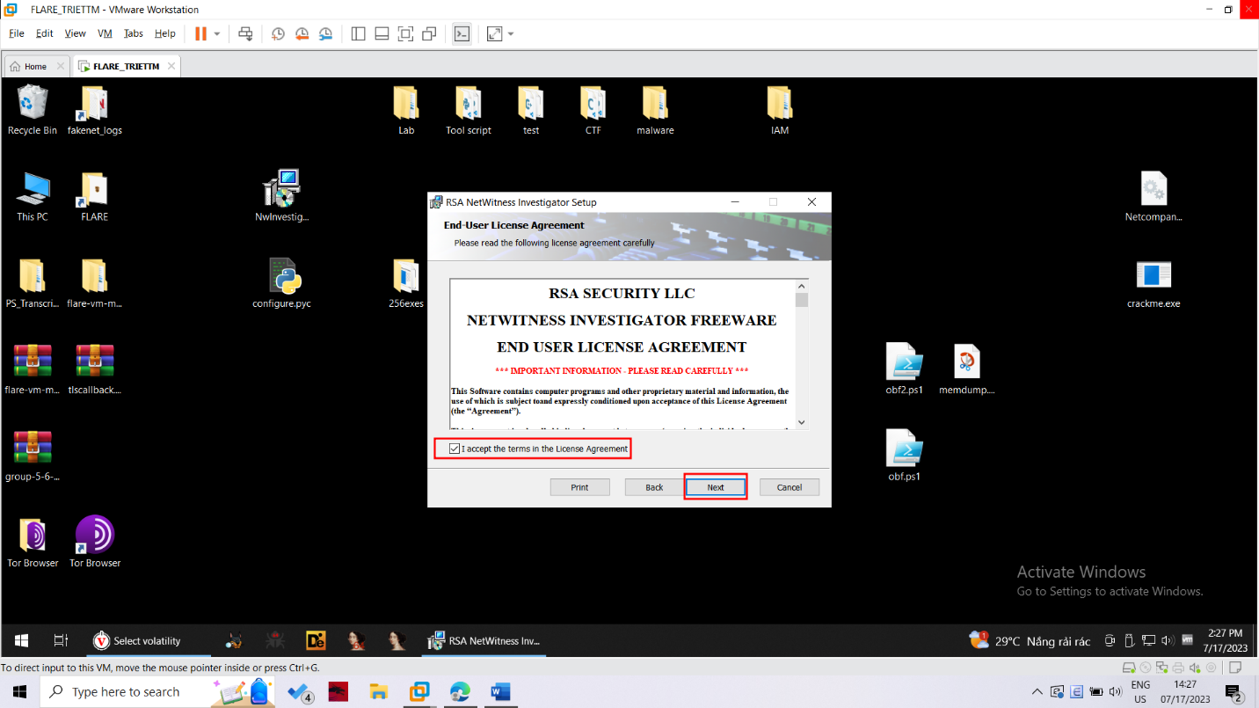

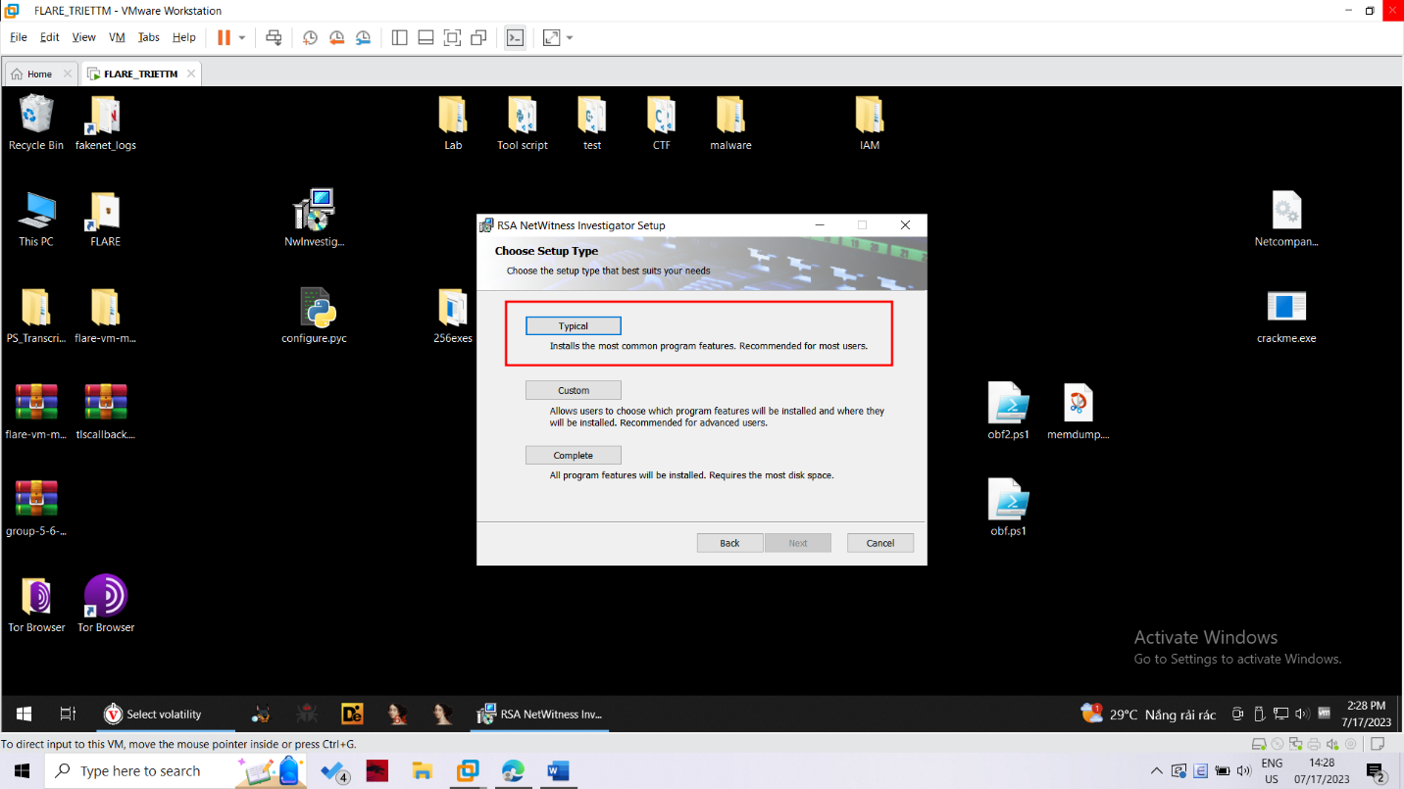

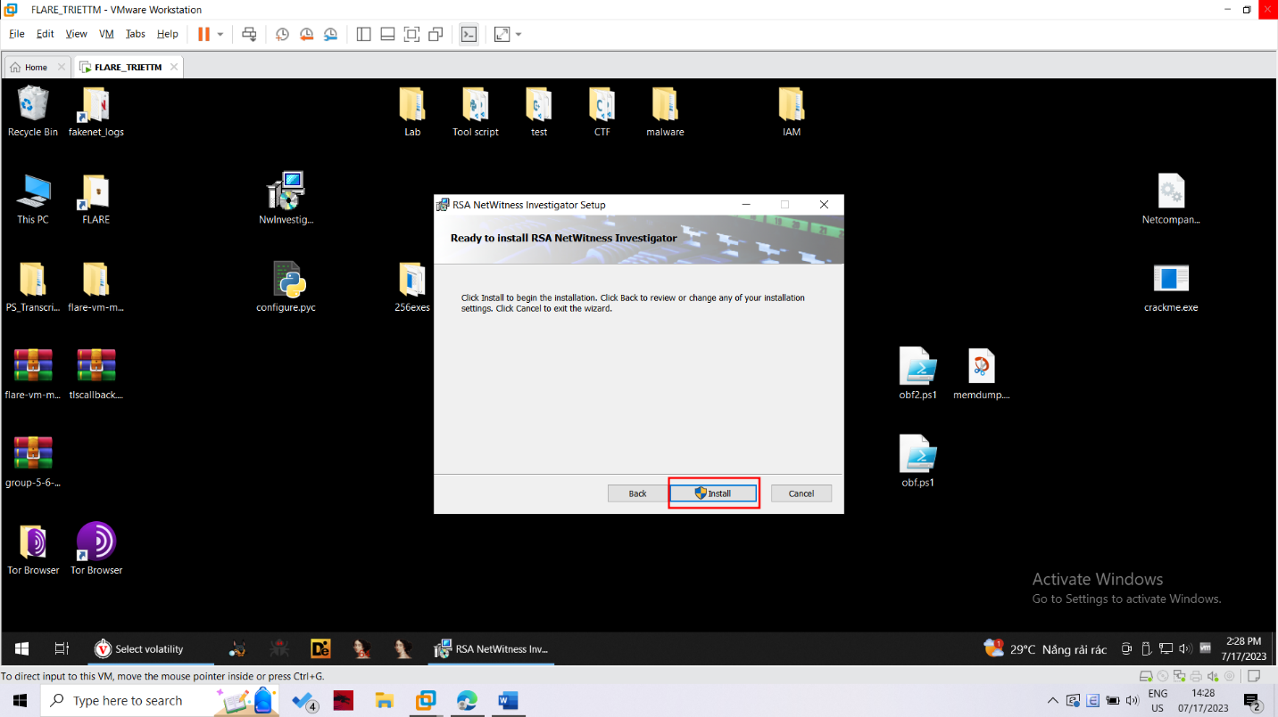

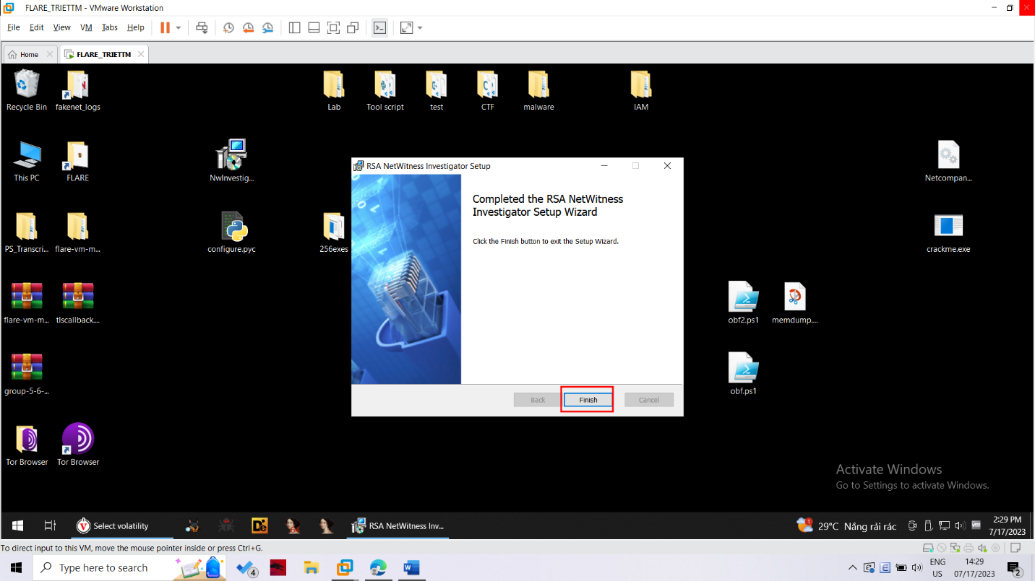

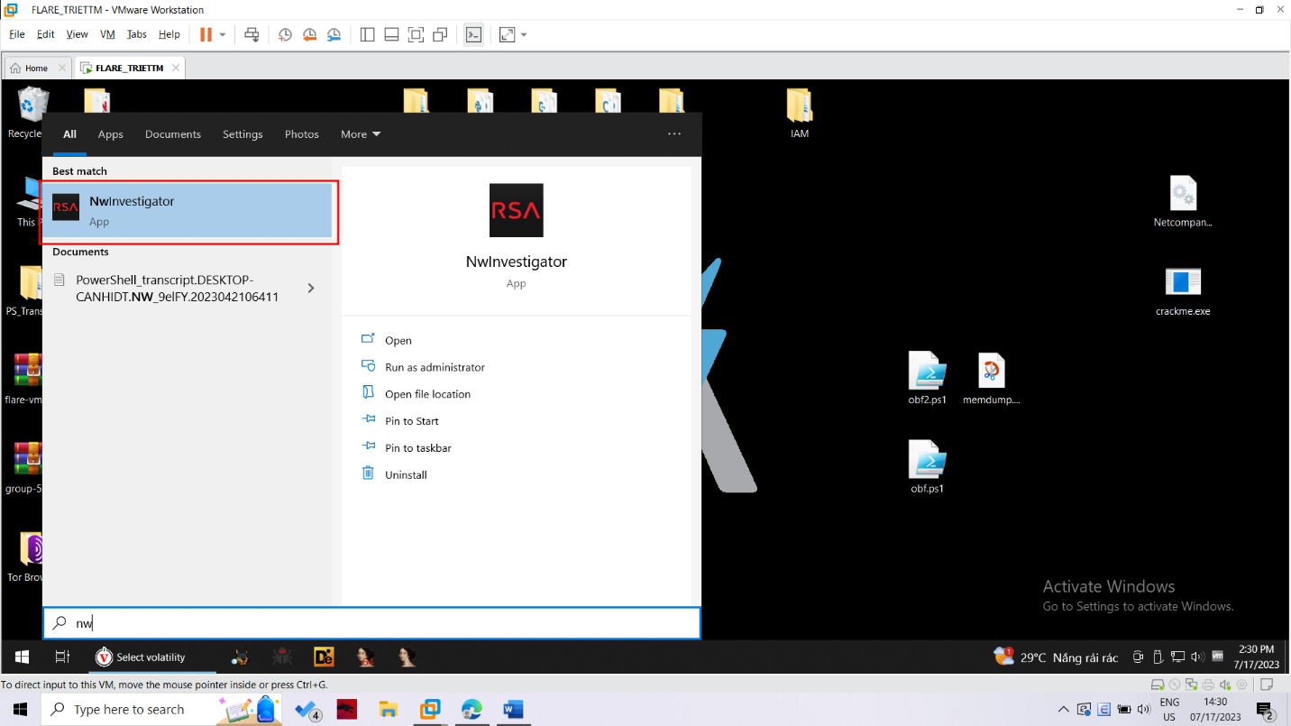

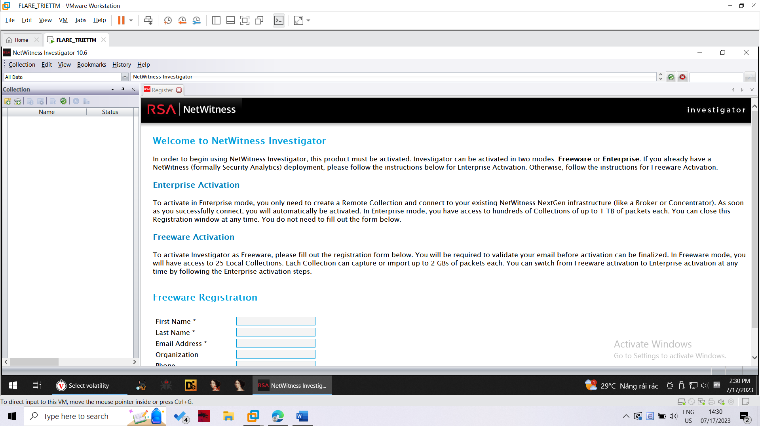

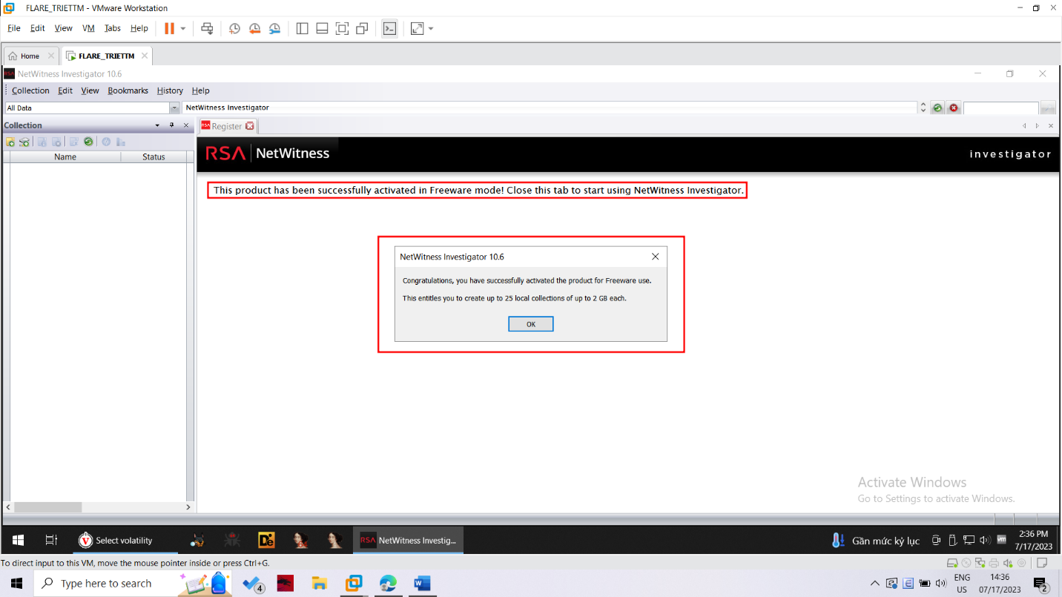

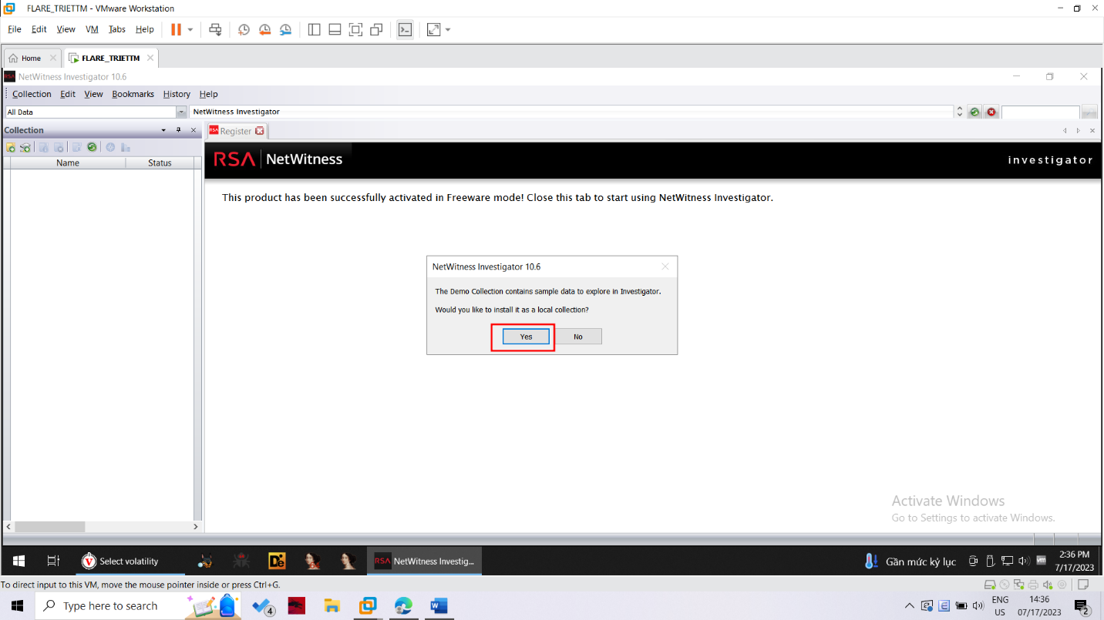

Getting Wireshark

If your machine doesn't have Wireshark, get it from http://www.wireshark.org/

Run Wireshark. Select the network adapter that goes to the Internet

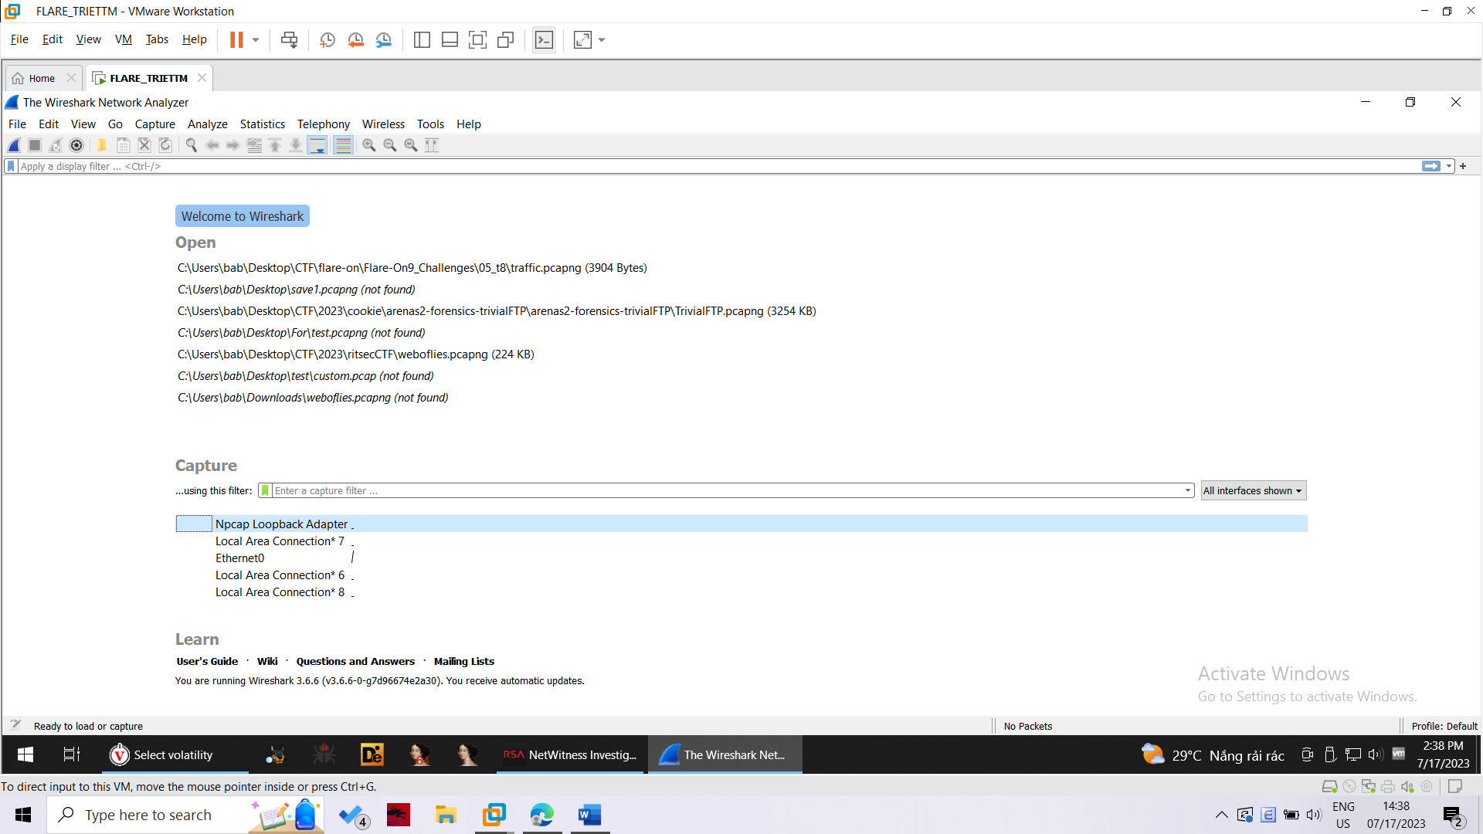

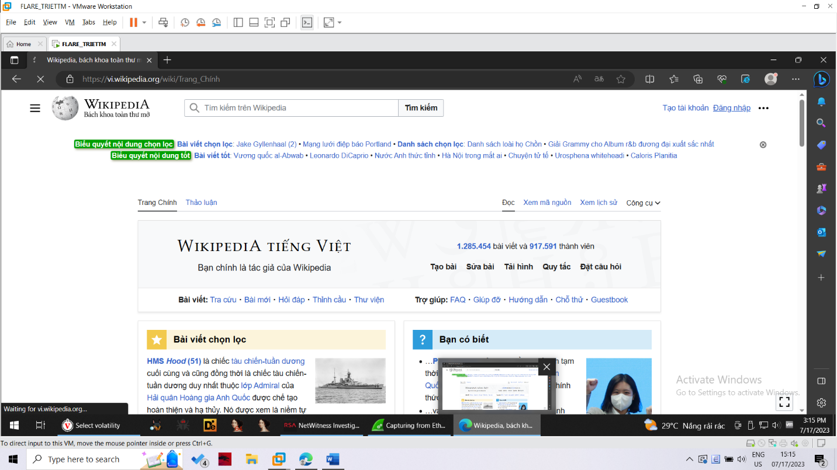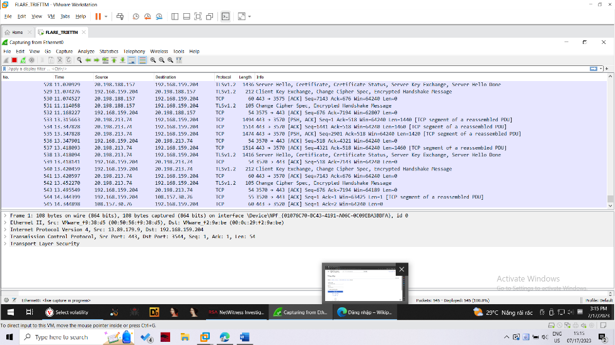

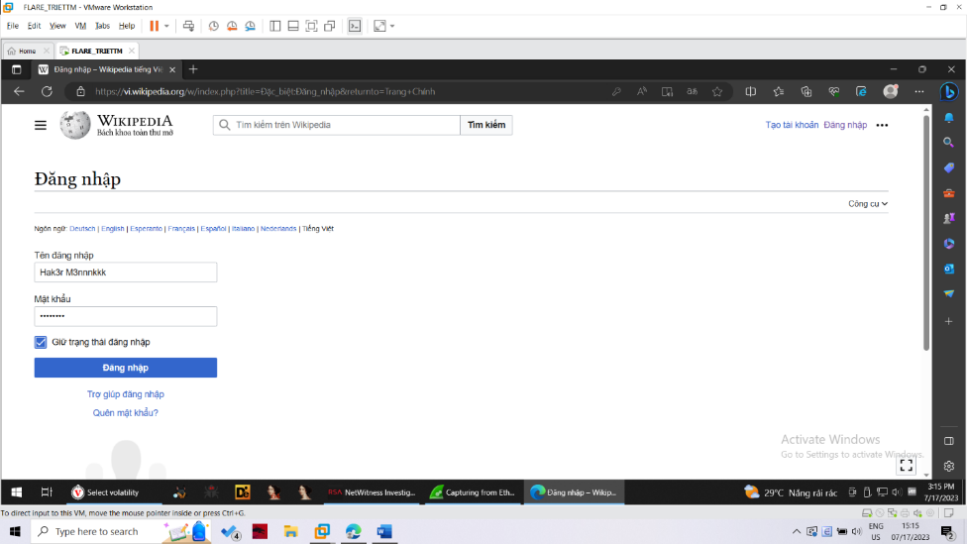

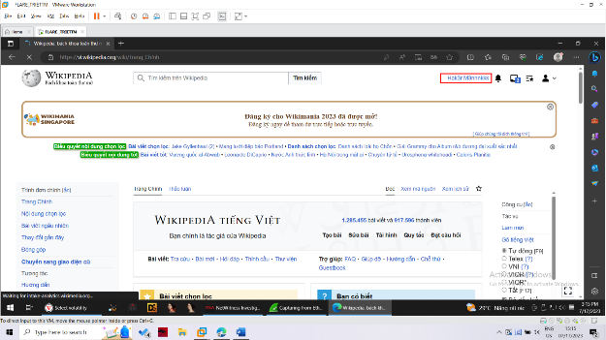

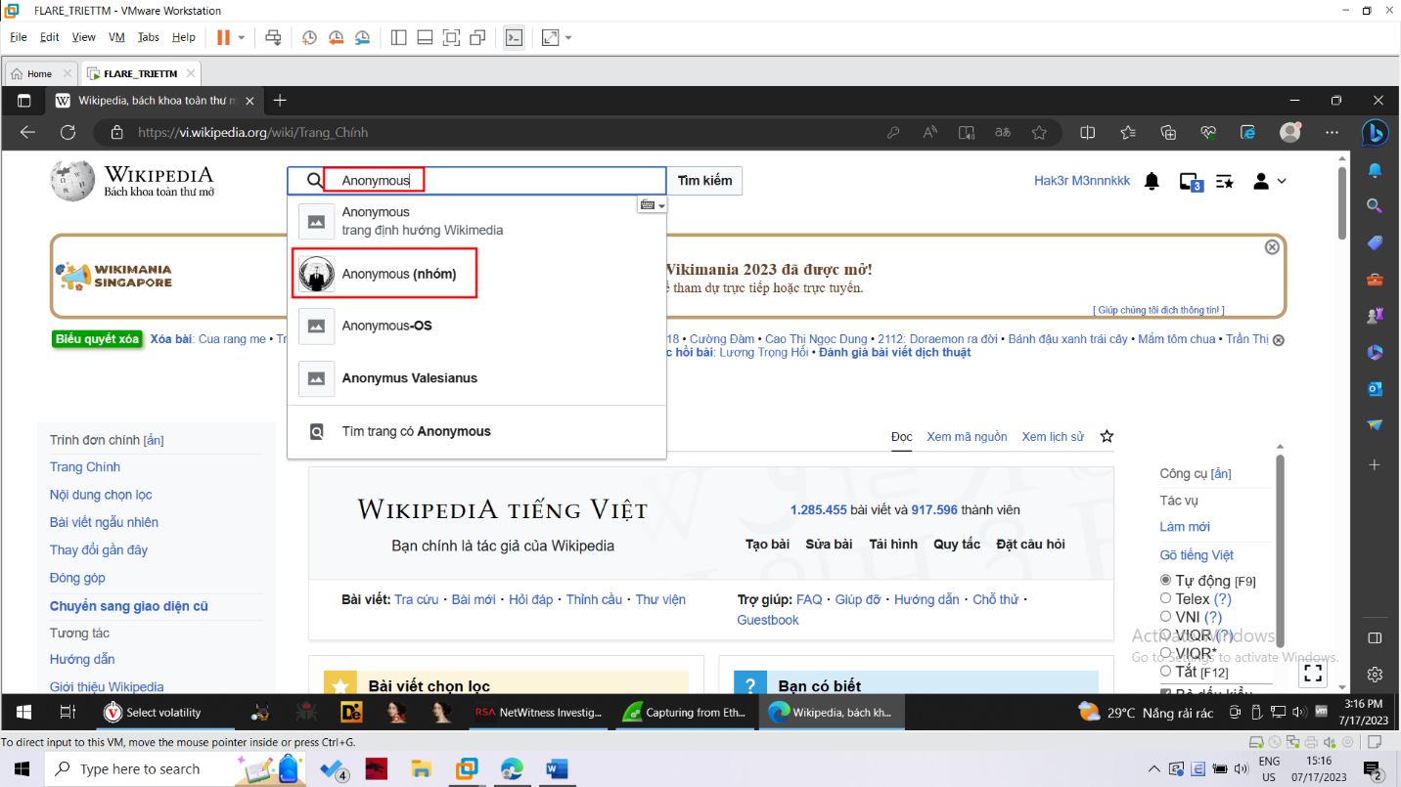

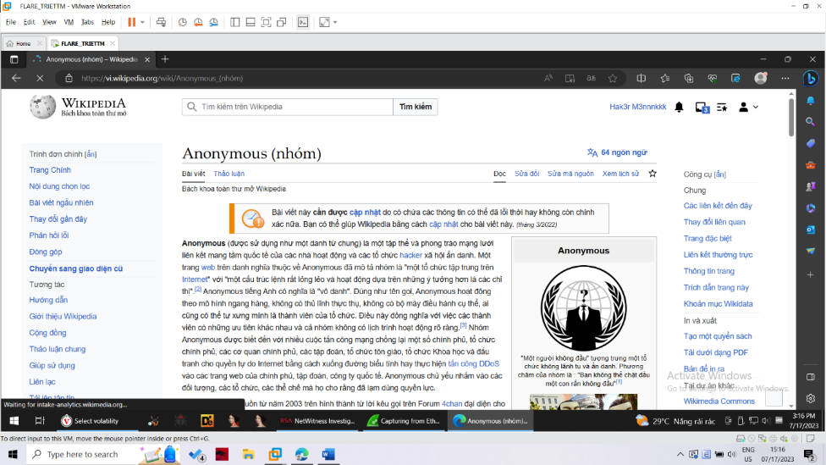

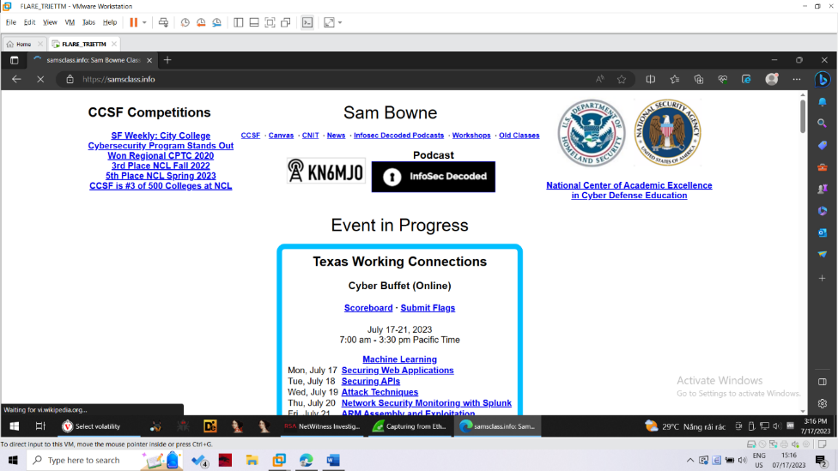

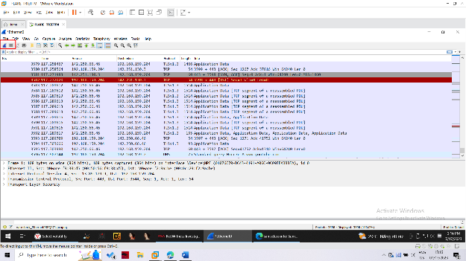

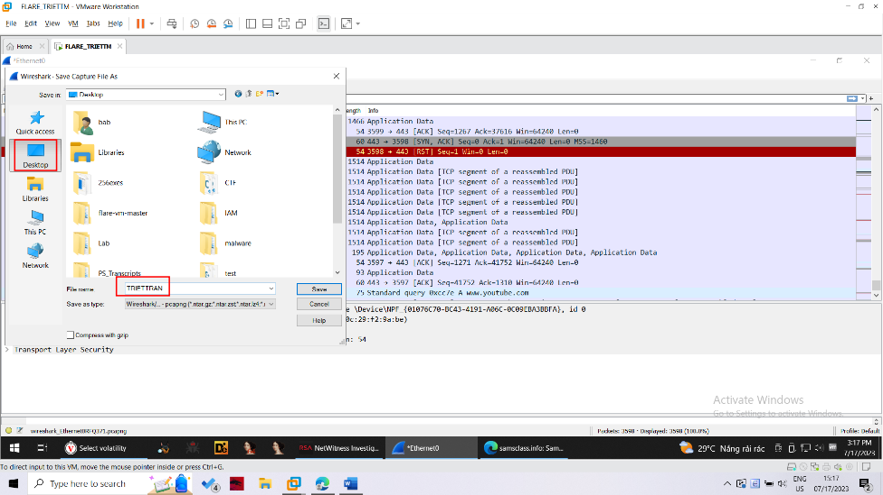

Importing the Evidence into NetWitness

In NetWitness, from the menu bar, click Collection, "New Local Collection".

Enter a Collection Name of YOURNAME (using your own name), as shown below:

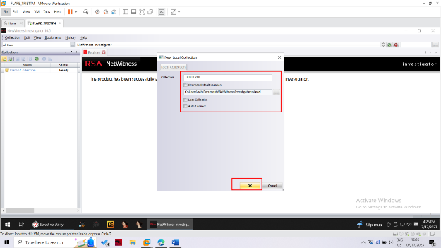

Click OK

In the left pane of NetWitness, double-click YOURNAME as shown below:

The status should show "Connecting", and after a few seconds, change to "Ready".

In NetWitness, from the menu bar, click Collection, "Import Packets".

Navigate to the YOURNAME.pcap file and double-click it.

The Status field shows progress--when I did it, I saw 1%, then 99%, then Done.

Analyzing Evidence

In the Collections pane of NetWitness, double-click YOURNAME again.

A Report appears, showing a list of traffic types, as shown below.

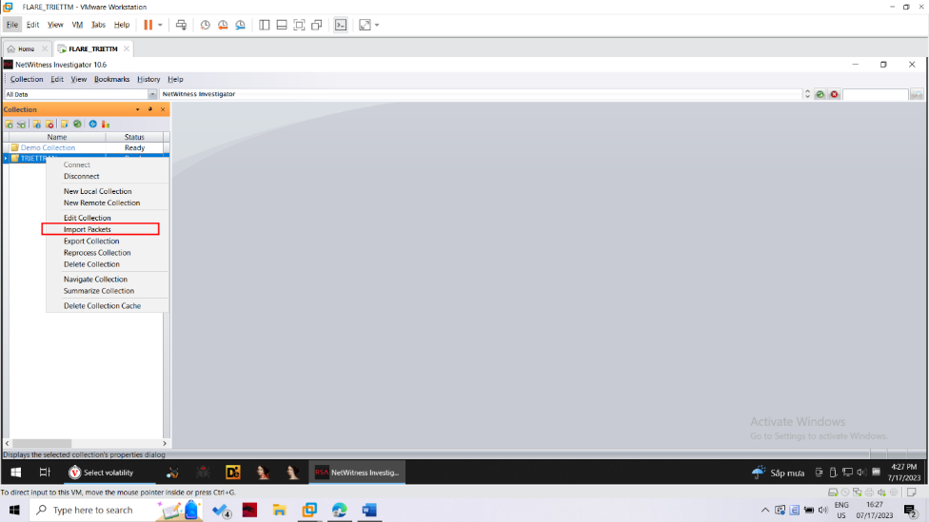

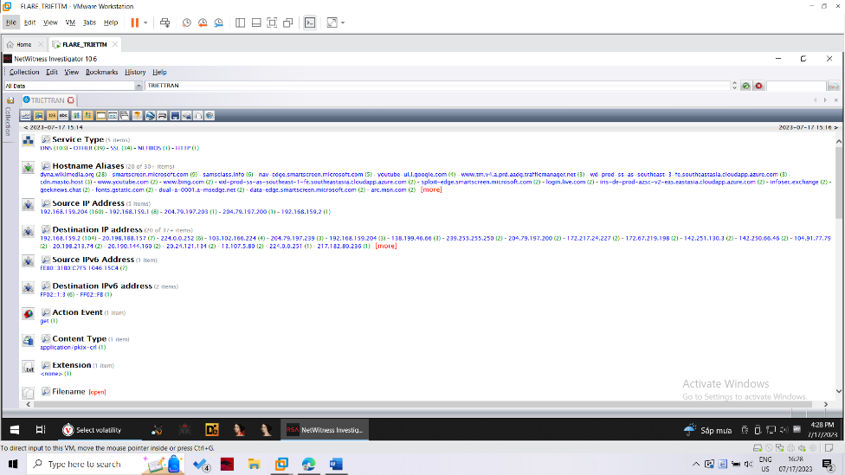

Note the items shown below:

● The Collections Tab has shrunk to the left to get out of the way

● The Toggle Timeline button shows a graph of the data

● The Drill Path shows the filters that have been applied to remove unimportant data--at the moment we are looking at all the data in the YOURNAME collection.

● In the Report, pairs of entries appear: a Value followed by a number of Sessions in parentheses, such as DHCP (2).

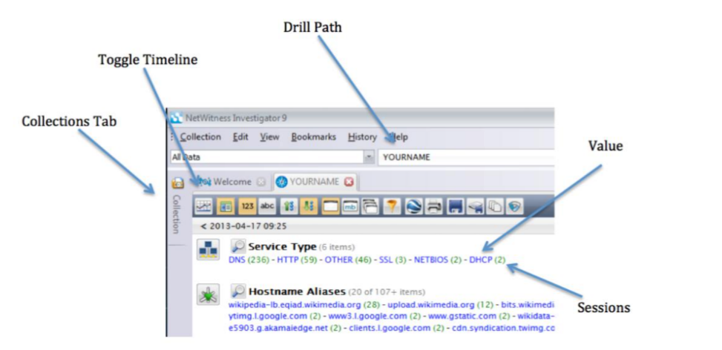

Click the Toggle Timeline button to show the Timeline, as shown below.

This shows the traffic as a graph, and can be used to focus down on particular intervals of time. It's not helpful in this project, so click the Toggle Timeline button again to hide it.

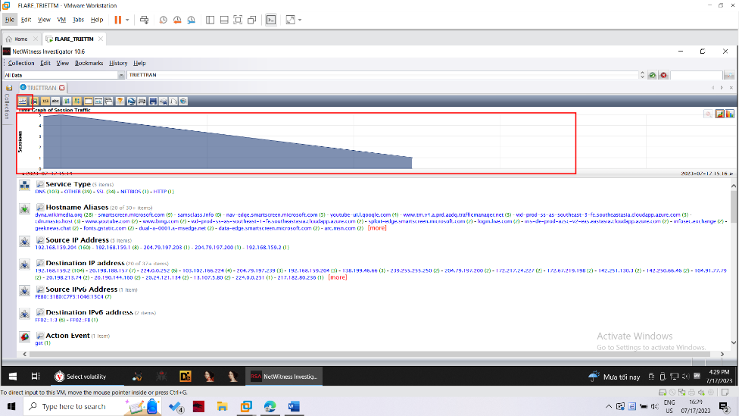

Finding the Wikipedia Login

In the Report, in the top section titled "Service Type", click the blue HTTP link.

This filters out all non-HTTP traffic. Notice that the Drill Path changes to "YOURNAME > HTTP", as shown below:

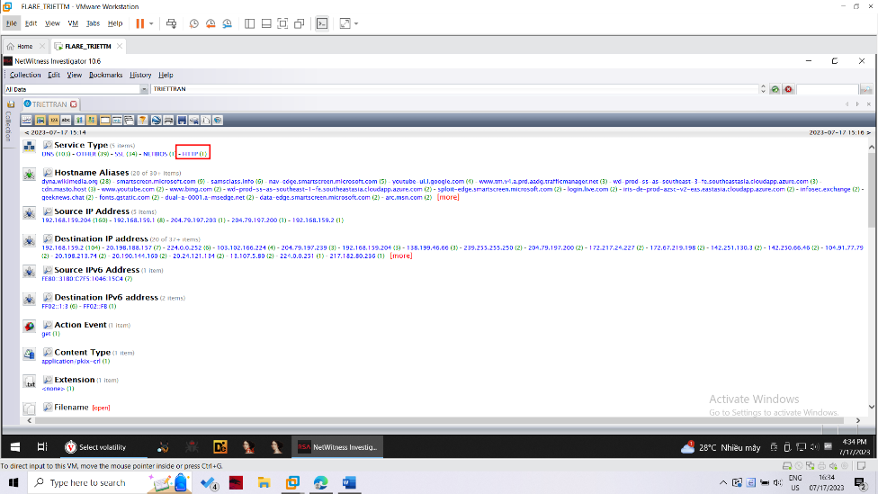

Now click the blue number in parentheses to the right of en.wikipedia.org -- in my case, it was "1". Your number may be different.

This shows the sessions with many details, as shown below. The Logs pane on the right is wasting space--close it by clicking on its X button.

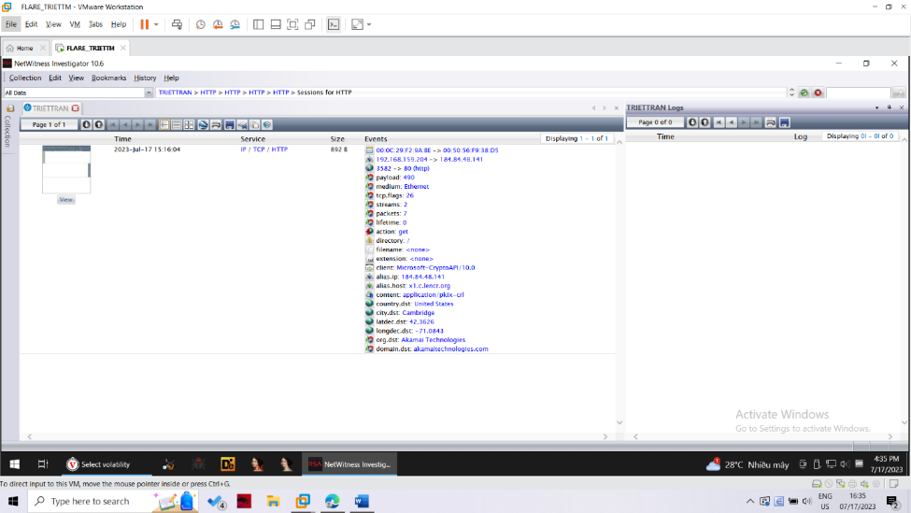

This has an error that wiki use https so we can not see the password. Test with another http login page below

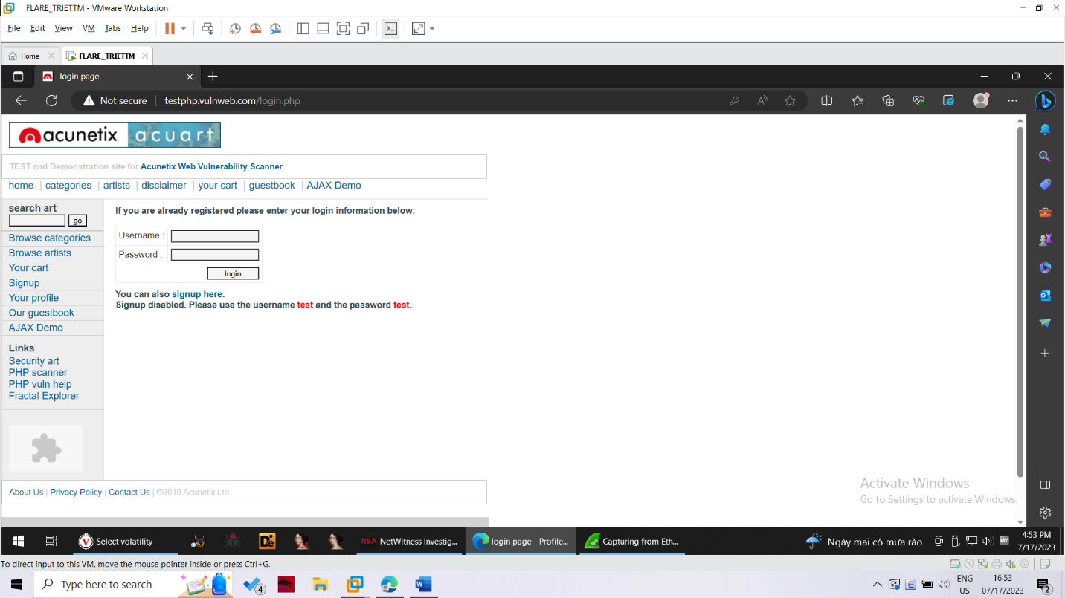

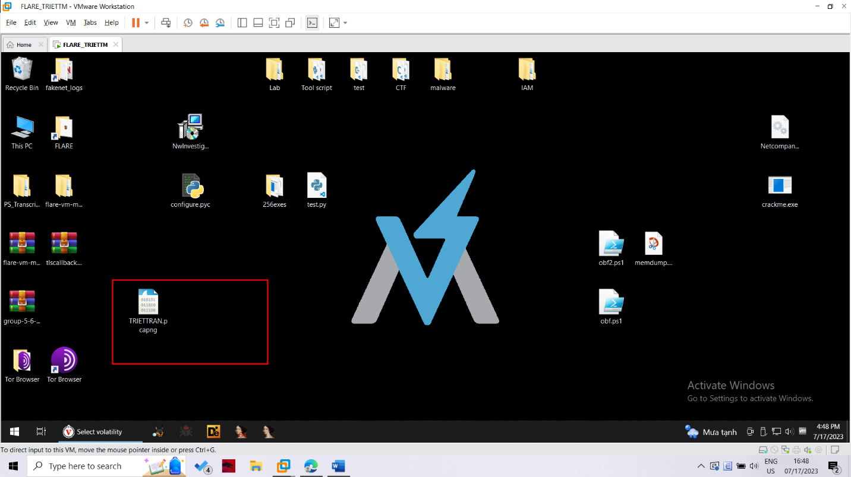

New pcap file

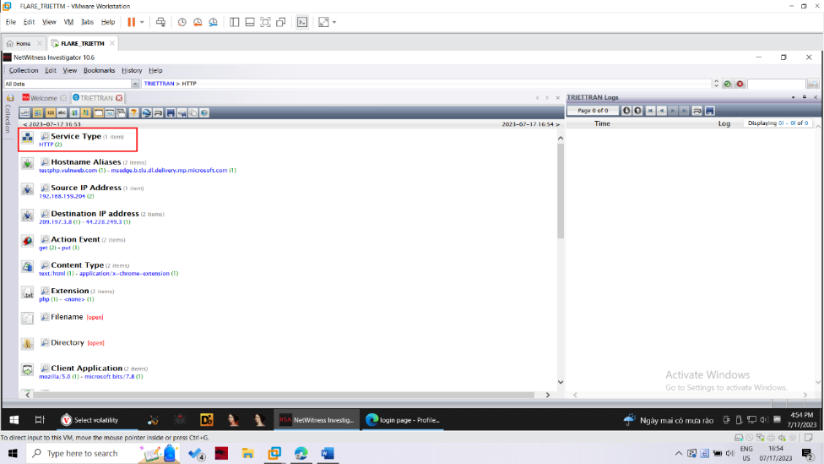

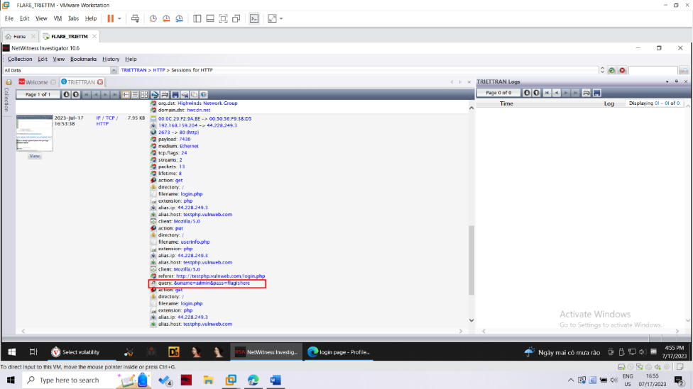

Viewing a Reconstruction

At the top center of the NetWitness window, in the Drill Path, click the blue HTTP.

In the "Hostname Aliases" section, click samsclass.info

In the "Hostname Aliases" section, click the number to the right of "samsclass.info"--in my case, it was a 3

Once again, the Logs pane is in the way--close it.

The HTTP sessions with the samsclass.info server are displayed, as shown below:

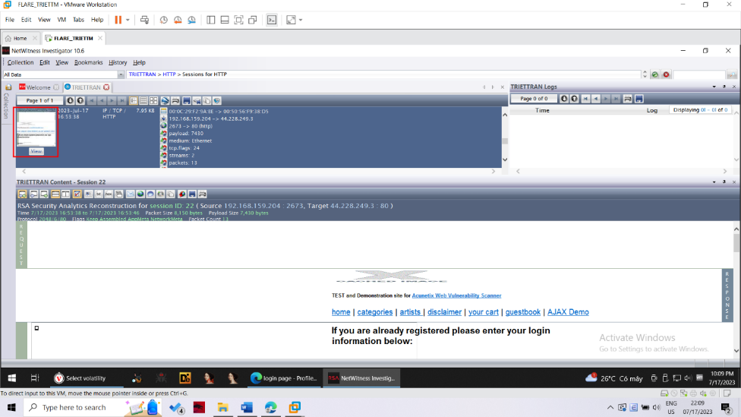

On the left side of the Report for each session, there is an icon showing how the Web page looks, with a gray View button.

Click the gray View button.

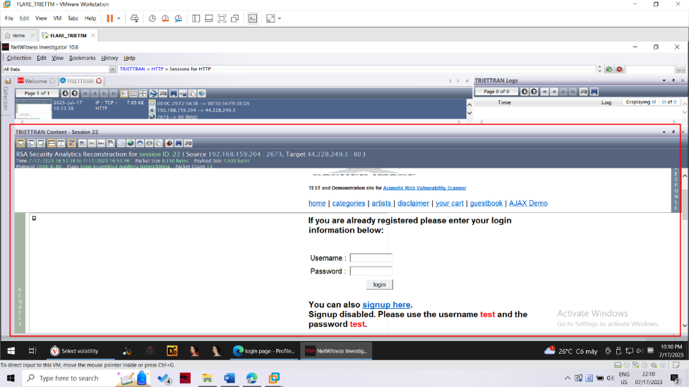

**Lab 14: Finding Items with NetWitness**

Task

Load the captured packets into NetWitness.

Find these items, and save an image of your whole desktop when you do.

FTP Download

Find an FTP download of a ZIP file.

Save an image like this one, showing the name of the downloaded file.

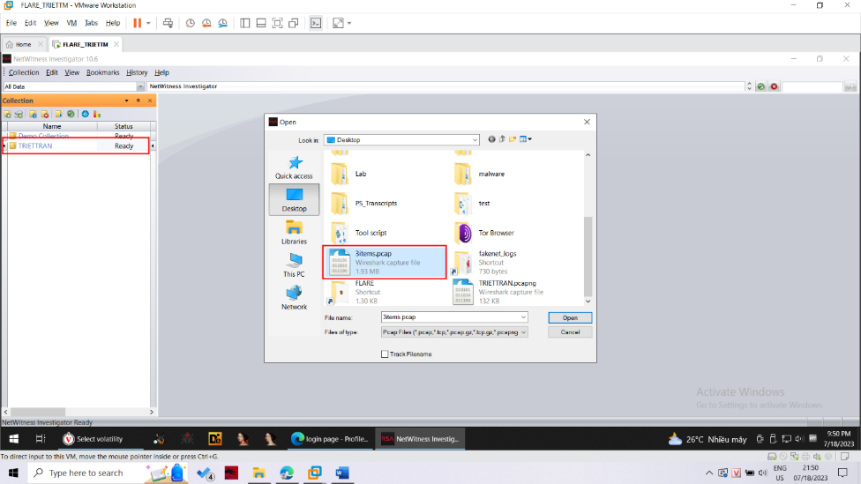

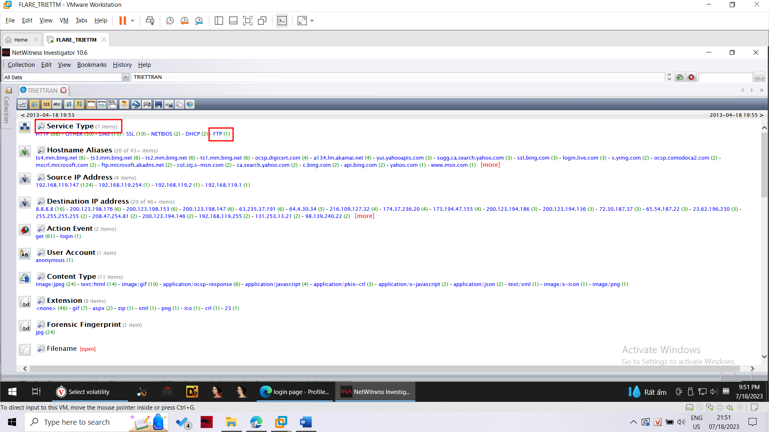

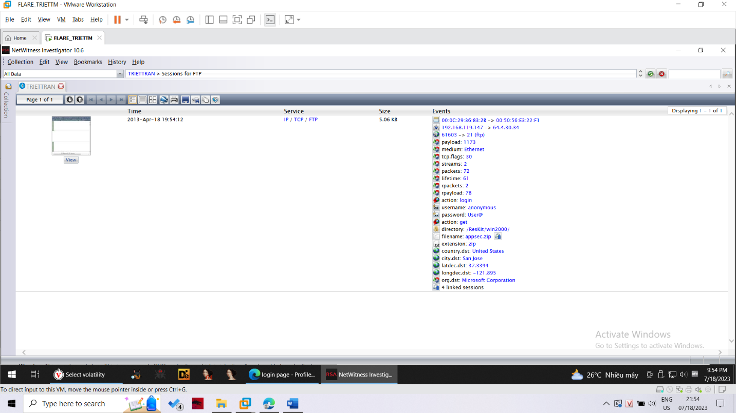

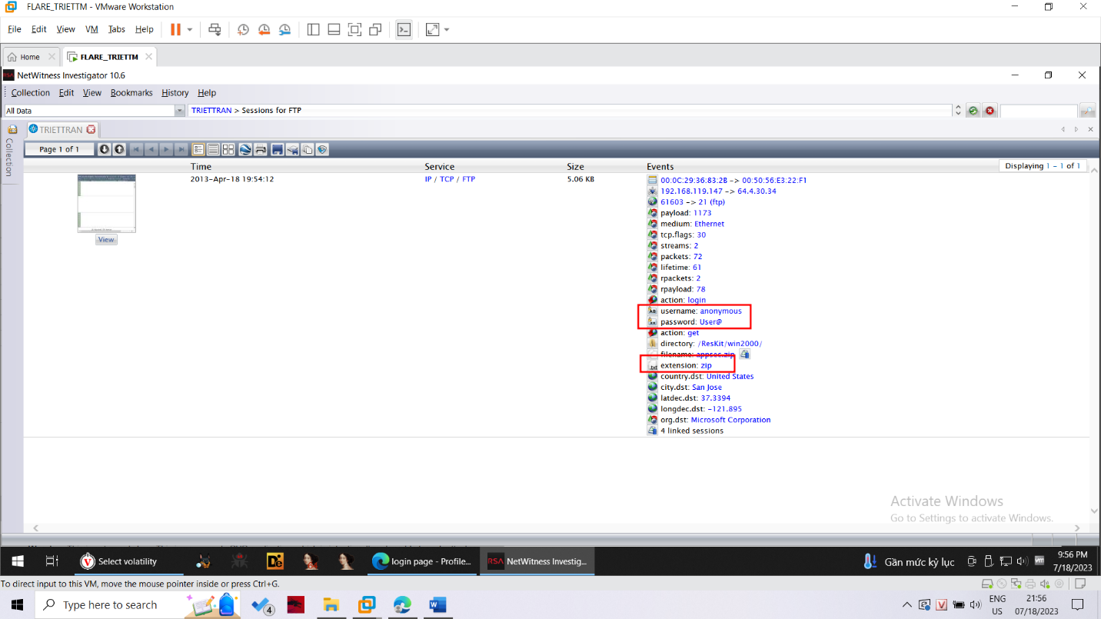

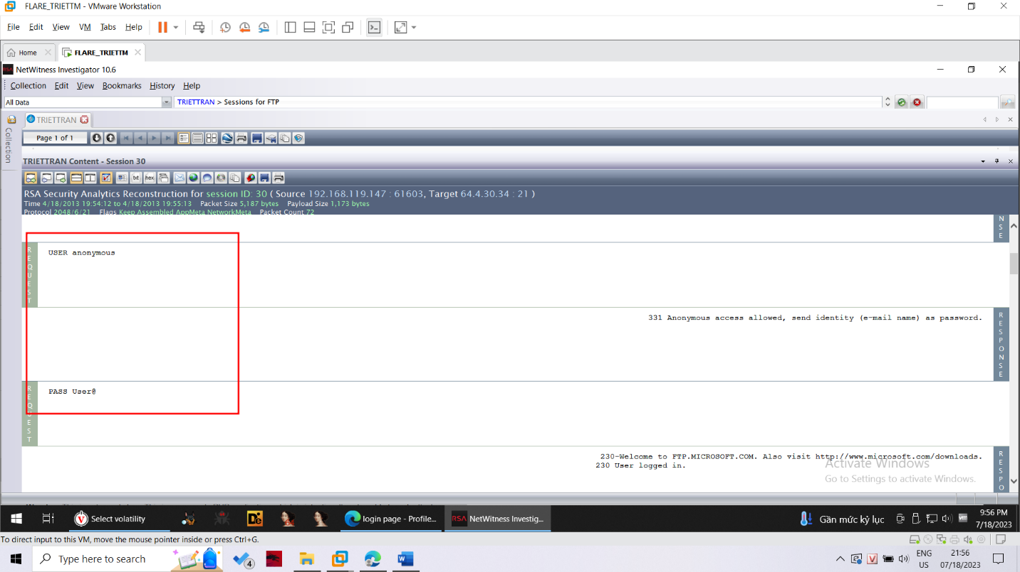

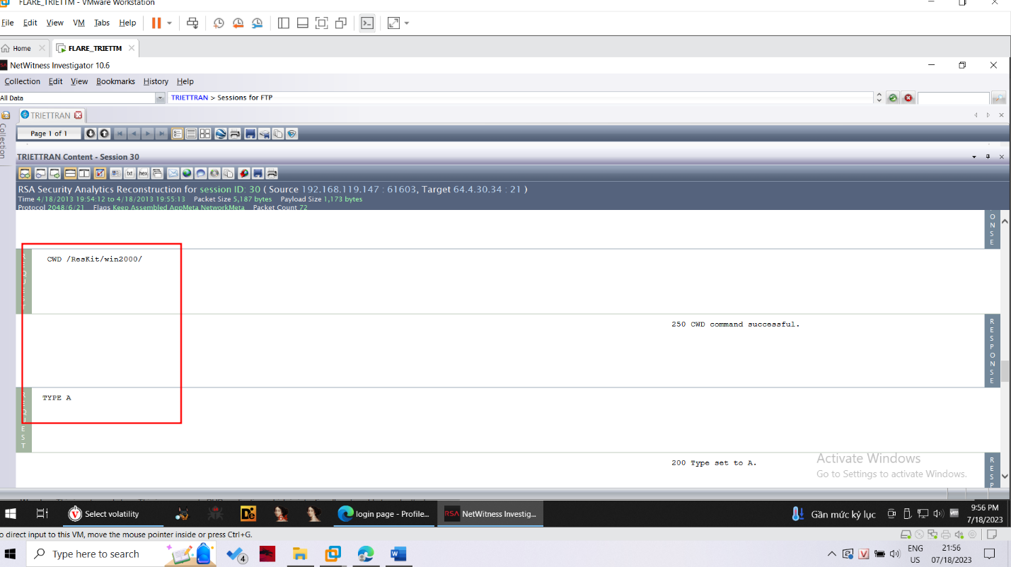

Yahoo Search

Find reconstructed Yahoo search page.

Save an image like this one, showing the term which was searched for.

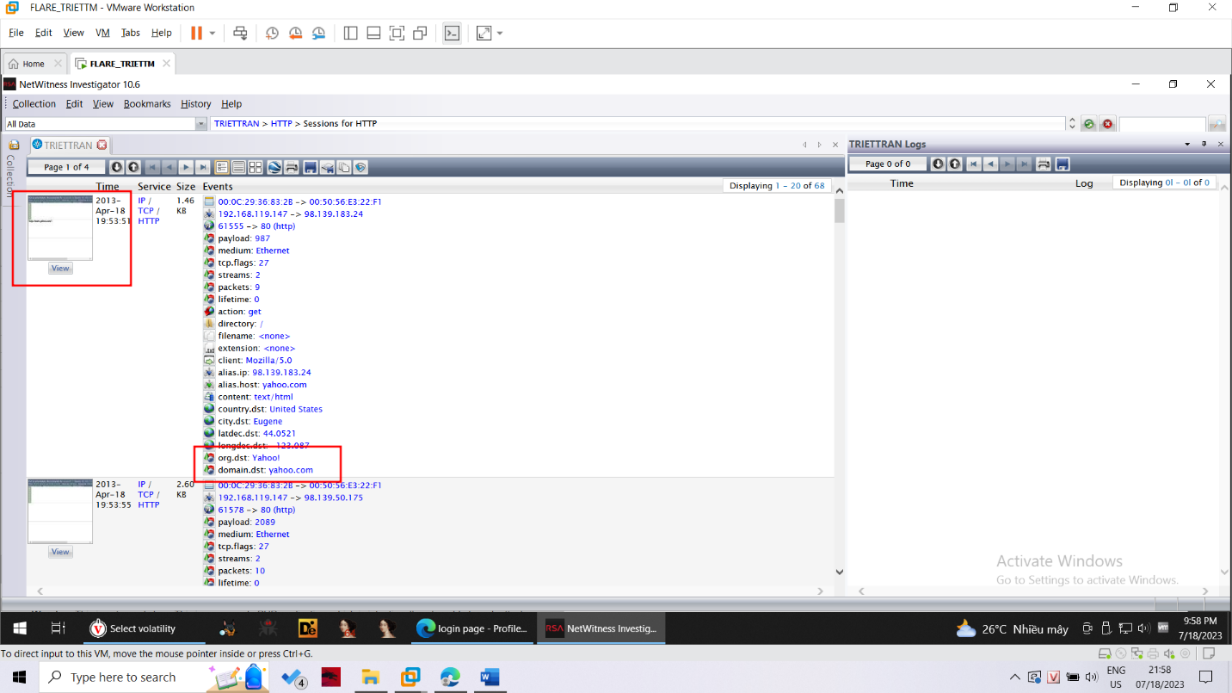

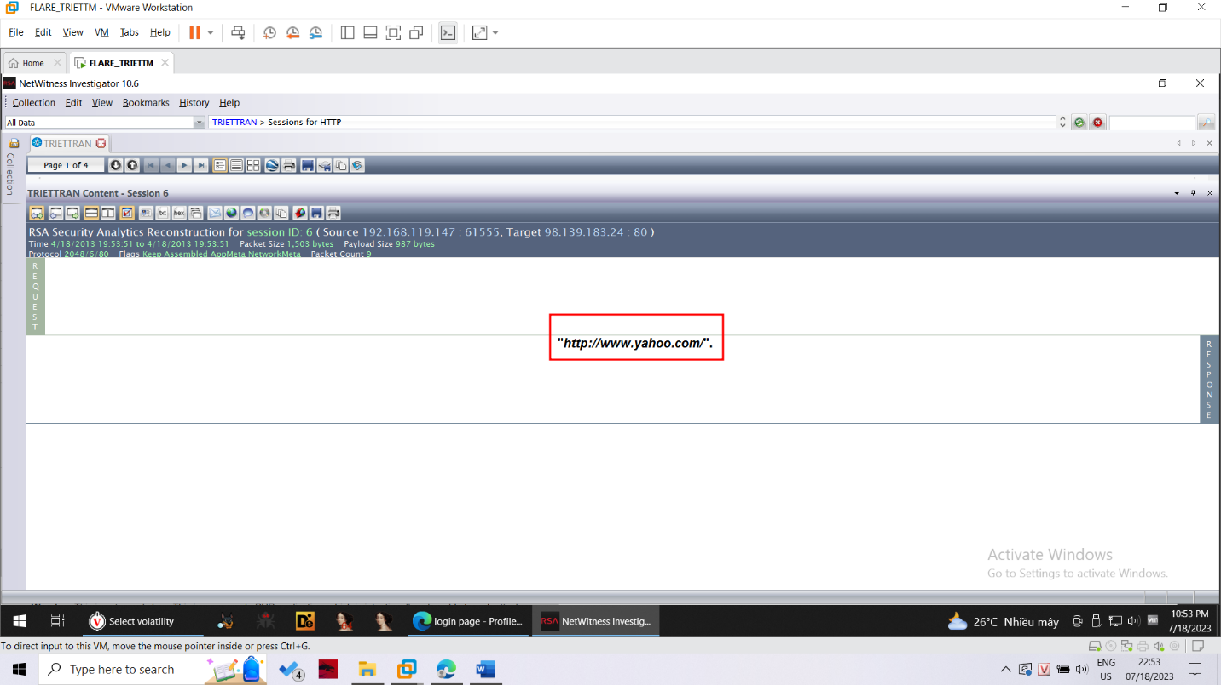

Gear Image

Find this image that was viewed in a reconstructed page. Your image should have some writing in the lower left corner which has been redacted from my sample image below.

